Community Page

Title:
Community

Copy:
Today, more than 40,000 cannabis prisoners in the United States are serving time for what is no longer a crime. This cannot stand. LEVEL supports cannabis criminal justice reform.

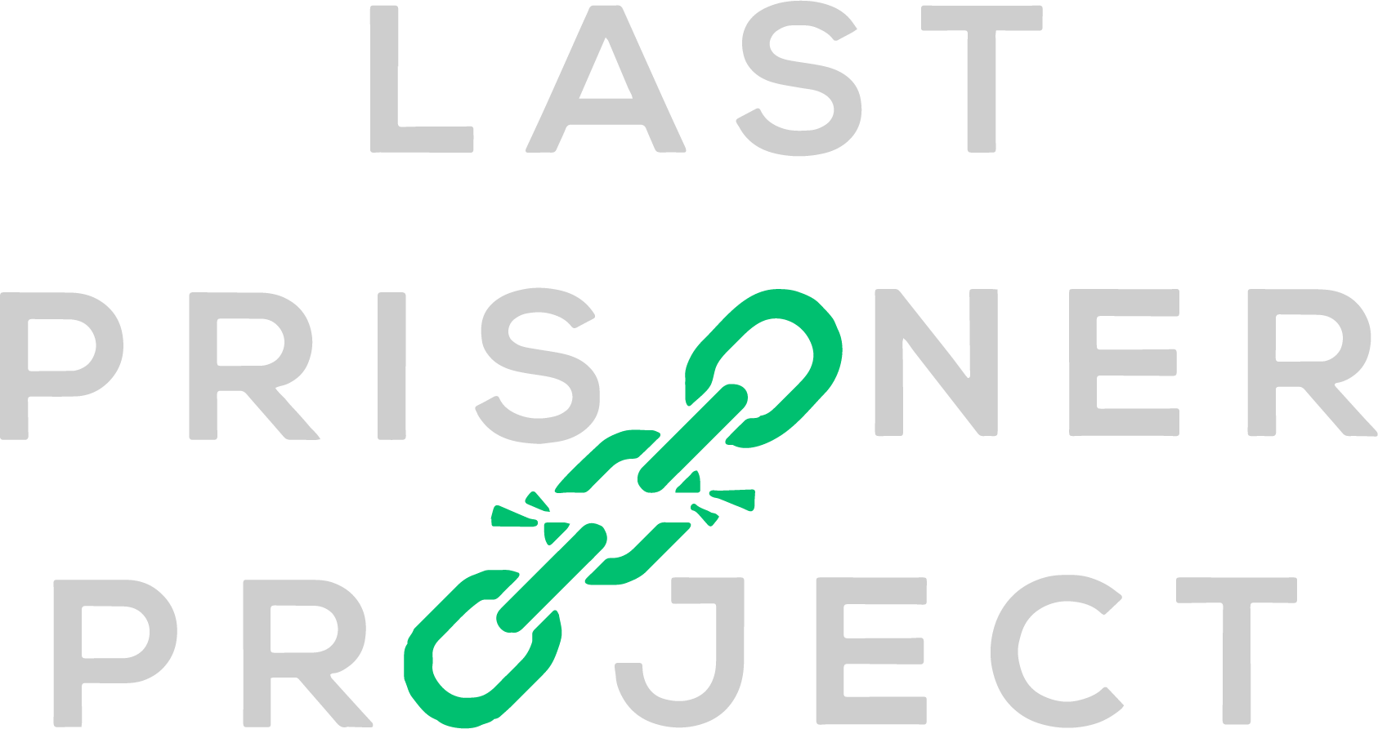

The military community has a long history of supporting one another, and as a veteran-owned business, LEVEL is honored and humbled to do its part in supporting veterans with therapeutic cannabis products.
